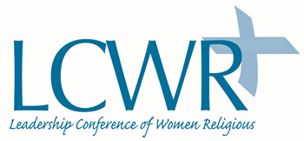

LCWR Statement on U.S. Withdrawal from New York Declaration for Refugees and Migrants

The world faces an unprecedented global migration crisis. More than 66 million people are on the move, more than at any time since World War II. Some 17.2 million are refugees; most are children. They have been forced from their homes displaced by war, natural disaster, and endemic poverty. These brothers and sisters of ours are quite literally running for their lives.

The Trump administration’s misguided decision to end U.S. participation in the New York Declaration for Refugees and Migrants is yet another example of the president’s attempts to wall off this nation and subvert its values. Furthermore, the withdrawal from the New York Declaration is yet another demonstration of the failure of U.S. leadership in the global community.

The United States has a long history of welcoming immigrants and sheltering refugees. Women religious have been blessed to be able to accompany and serve immigrant and refugee communities across this country and around the world for a very long time. We strongly object to any attempt to limit our ability to heed the scriptural command to welcome the stranger and care for our neighbors.

Catholic sisters remain committed to welcoming refugees and migrants and will continue to demand that the dignity and rights of all refugees and migrants, regardless of status, are honored.

LCWR is an association of leaders of congregations of Catholic sisters in the United States. The conference has nearly 1300 members, who represent more than 38,800 women religious in the United States. Founded in 1956, LCWR assists its members to collaboratively carry out their service of leadership to further the mission of the Gospel in today’s world.

Contact: Annmarie Sanders, IHM asanders@lcwr.org

